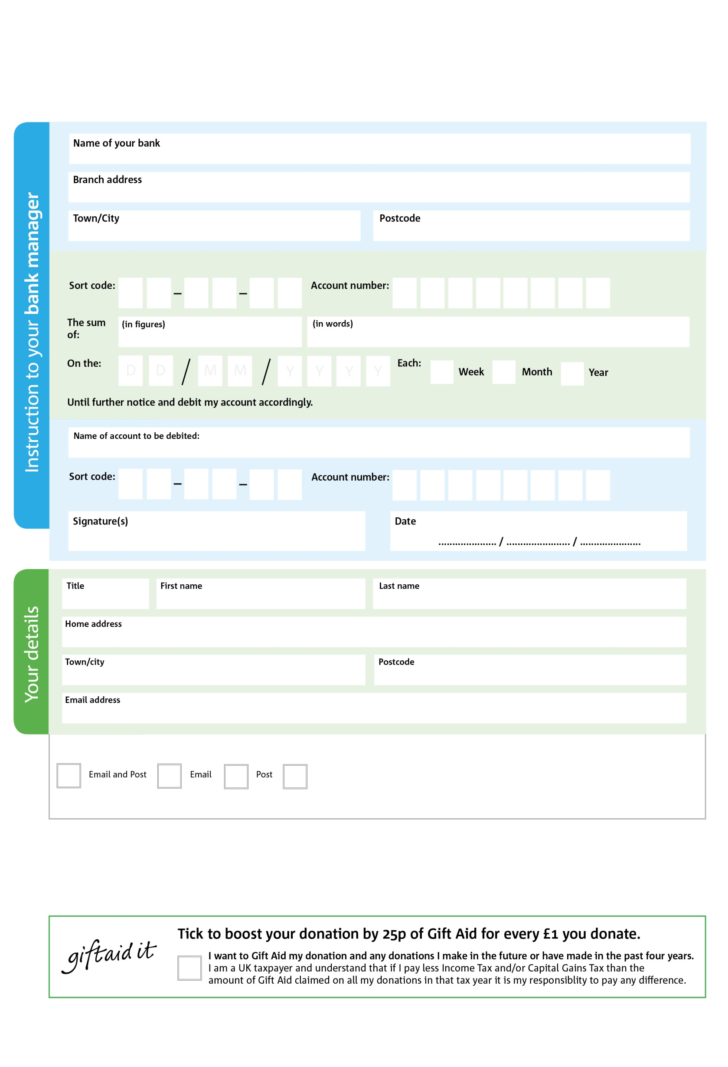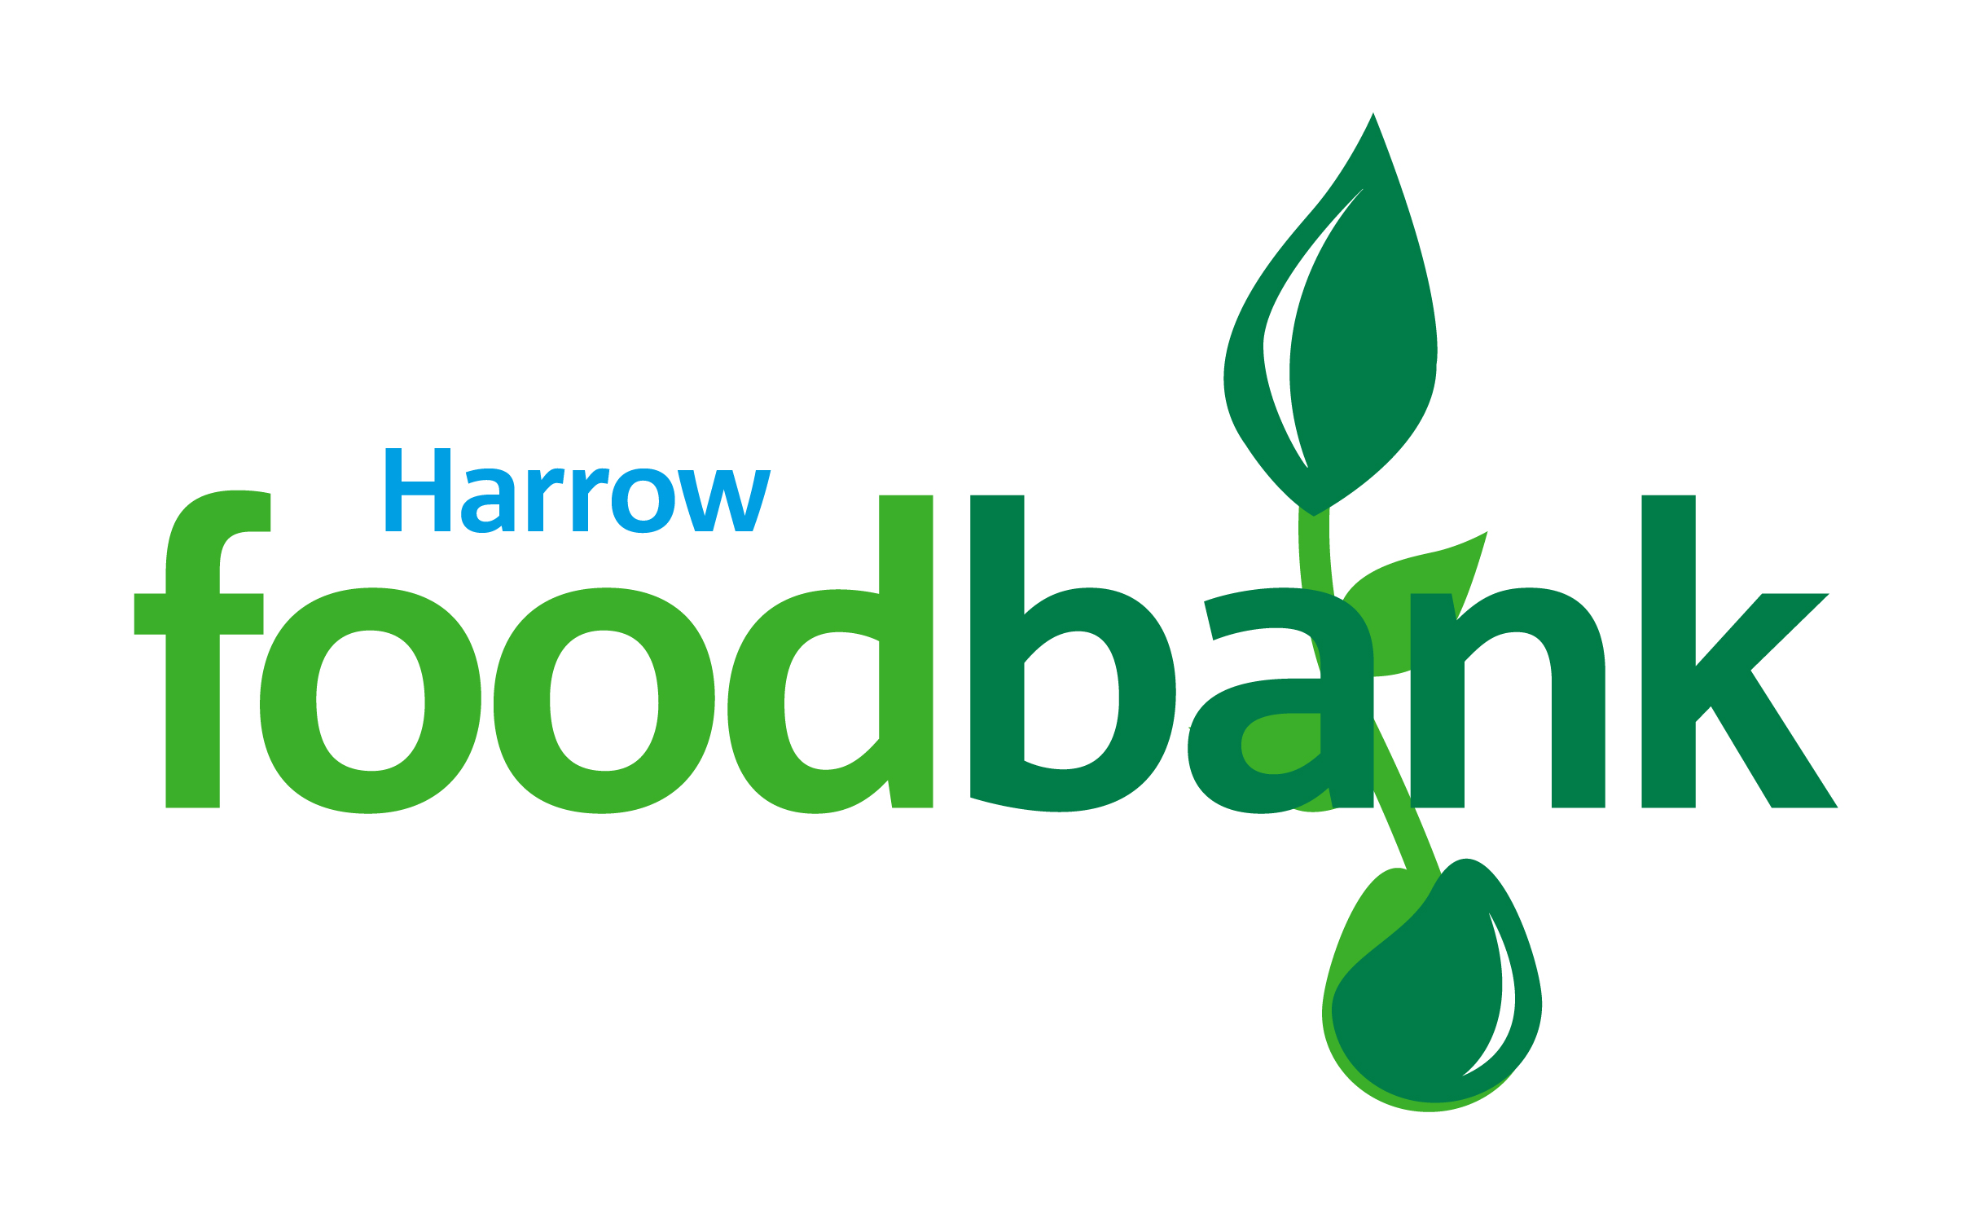

Please pay Harrow Foodbank,

I do not wish to receive future communications from Harrow Foodbank

We would love to keep you up to date with information about Harrow Foodbank. Please tick your preference:

You can change your preferences any time by contacting us on 020 8416 7344 or emailing us at info@harrow.foodbank.org.uk

**Data protection**

*'Harrow Foodbank is committed to protecting your privacy and will process your personal data in accordance with current Data Protection legislation. Harrow Foodbank collects information to keep in touch with you and supply you with information relating to our work. To unsubscribe from our newsletter, send a message to the email address above with the word unsubscribe in the subject line. A full data privacy statement for financial donors is available from the foodbank on request.’*

2X

V

7

V

9

6

V

0

V

4

V

2

V

6

V

4

V

2

33

9

0

3

**Please pass this form onto the foodbank, using the foodbank’s address at the bottom, who will save a copy for their records.   
They will then send it onto your named bank or building society.**

Reg. Charity No: 1154292 | Reg. in England & Wales

POSTAL ADDRESS: Harrow Foodbank,Unit F2, Phoenix Business Centre, Rosslyn Crescent, Harrow, HA1 2SP

**Standing Order Mandate**

**www.harrow.foodbank.org.uk**

You can change your preferences any time by contacting us on XXXXXXXXXXX or emailing us at XXXX@XXXXXXXXXX.foodbank.org.uk

I do not wish to receive future communications from XXXXXX Foodbank